**Vite vs. Next.js: Quick Overview**

Vite and Next.js aren't direct apples-to-apples competitors—Vite is primarily a fast build tool and dev server (often paired with React for SPAs), while Next.js is a **full-featured React framework with extras like server-side rendering (SSR), built-in routing, and API handling**. That said, they're often compared for React projects, especially when deciding on a setup for apps like yours: a finance dashboard with minimal summary views that deep-link (via routing) to detailed data.

Based on recent 2025 comparisons, here's a side-by-side breakdown tailored to your use case (lightweight frontend with client-side navigation and data fetching):

|  |  |  |
| --- | --- | --- |
| Aspect | Vite (with React) | Next.js |
| Best For | SPAs, prototyping, fast dev cycles. Ideal for your minimal summary + deeplink setup if it's mostly client-side. | Full-stack apps, SSR/SEO-heavy sites. Overkill for pure client-side unless you add server features later. |
| Dev Speed | Extremely fast HMR (hot module replacement) and cold starts—under 1s for most apps. Great for iterating on UI/data views. | Solid, but slower than Vite due to SSR overhead. Turbopack (Next's new bundler) helps, but still lags in pure dev speed. |
| Bundle Size/Perf | Smaller bundles, lighter runtime. Perfect for finance apps where you want quick loads for summaries without bloat. | Larger due to framework features; optimized for initial loads via SSR but can feel heavier for SPAs. |
| Routing/Deeplinks | Use React Router (easy integration). Handles your "click summary → show details" flow seamlessly as client-side navigation. | Built-in file-based routing—zero config, but adds framework lock-in. |
| Data Fetching | Flexible: Use TanStack Query or SWR for async data on deeplinks. No built-ins, so you pick what fits. | App Router with server components for data—powerful but more opinionated. |
| Learning Curve | Low if you know React; minimal setup. | Steeper due to conventions (e.g., pages vs. app router). |
| When to Avoid | If you later need SSR/API routes (e.g., for public finance reports). | For simple, internal tools—it's like using a Swiss Army knife for a screw. |
| Popularity (2025) | 73%+ usage for build tools; rising for SPAs. | 57% for frameworks; dominant for e-commerce/public apps. |

**Recommendation for Your Finance App**

Go with **Vite + React**—it's "better" (lighter, faster) for your described setup: minimal summaries with client-side deeplinks to more data. This keeps things simple, performant, and easy to maintain without Next.js's overhead. Your app sounds like an internal/external dashboard (not SEO-critical), so Vite's speed will shine during development and deployment. For routing, add React Router v7—it's plug-and-play and handles deep links perfectly.

**Quick Setup Steps**

1. Init: npm create vite@latest my-finance-app -- --template react (uses npm as default package manager; swap for yarn/pnpm if preferred).
2. Install routing: npm i react-router-dom.
3. Basic structure:
   * App.jsx: Wrap with <BrowserRouter>.
   * Summary view: <Link to="/details/:id"> for deeplinks.
   * Details page: Use useParams() to fetch/show more data (e.g., via API call).
4. Data: Integrate a query lib like @tanstack/react-query for caching summaries and lazy-loading details.

If your app grows to need SSR (e.g., for shareable finance reports) or backend APIs, migrate to Next.js—it's straightforward from Vite. On "package manager": If you meant npm/yarn/pnpm, npm is fine for both; pnpm is fastest for large deps in finance libs.

**What is SSR (Server-Side Rendering)?**

Server-Side Rendering (SSR) is when a web app's HTML is generated on the server for each request, rather than in the browser (client-side). The server processes the app’s code, fetches data, and sends a fully rendered HTML page to the client. This contrasts with client-side rendering (CSR), where the browser downloads a minimal HTML shell and JavaScript to render the UI and fetch data afterward.

**Why SSR?**

* **SEO**: Search engines see fully rendered content, great for public-facing pages (e.g., finance reports).
* **Faster initial load**: Users see content quicker since the server sends a complete page.
* **Downside**: Slower dev cycles and heavier server load compared to CSR (like Vite’s default setup).

**SSR in the Context of Your Finance App**

In your app, with minimal summary data and deeplinks to details, SSR isn’t critical since it sounds like an internal dashboard or lightweight SPA. However, if you were to make summary pages publicly shareable (e.g., a stock report at yourapp.com/stock/AAPL), SSR ensures search engines index the content and users see data instantly without a JavaScript “loading” flicker.

**Example: SSR with Next.js vs. CSR with Vite**

Let’s say your finance app shows a summary of stock prices, and clicking a stock (e.g., AAPL) deeplinks to /stock/AAPL with detailed charts.

**1. SSR with Next.js (App Router)**

Next.js handles SSR out of the box. Here’s how it works for your app:

**Code Example** (Next.js app/stock/[ticker]/page.jsx):

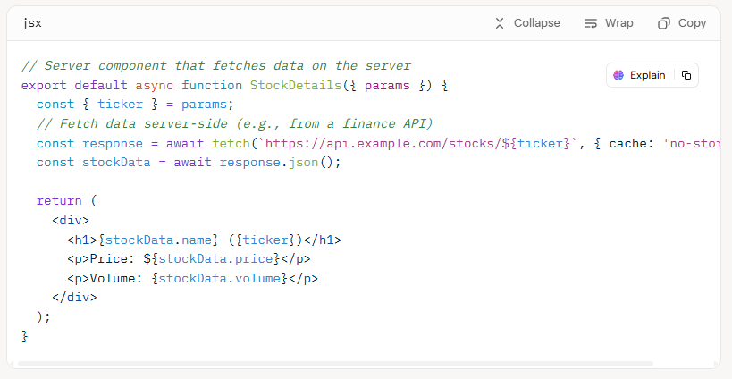

**How SSR Works Here**:

1. User visits /stock/AAPL.
2. Next.js server fetches AAPL data from an API during the request.
3. Server renders the HTML (with price, volume, etc.) and sends it to the browser.
4. Browser displays the page instantly; JavaScript “hydrates” it for interactivity (e.g., clicking to refresh data).

**Result**: The user sees the full stock details page immediately, and search engines index the content. But the server does more work per request.

**2. CSR with Vite + React (for Comparison)**

With Vite, rendering happens client-side, so the browser handles data fetching.

**Code Example** (Vite src/pages/StockDetails.jsx):

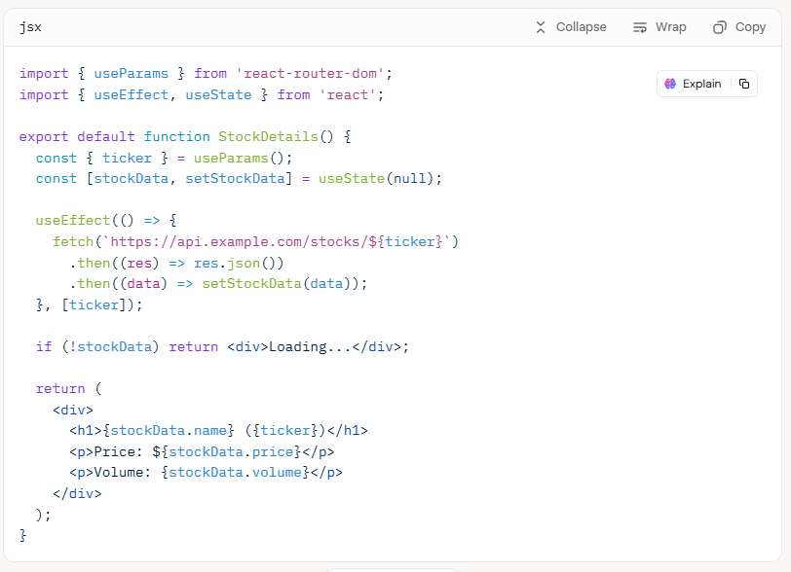

**How CSR Works Here**:

1. User visits /stock/AAPL.
2. Browser downloads minimal HTML + JavaScript bundle.
3. JavaScript runs, fetches AAPL data, and renders the UI.
4. User sees a “Loading...” state briefly until data loads.

**Result**: Faster dev setup and lighter server load, but initial render may flicker, and SEO is weaker unless you add prerendering.

**When to Use SSR for Your App**

Use SSR (via Next.js) if:

* You need public-facing pages (e.g., shareable stock summaries) for SEO or social sharing (Open Graph previews).
* Users expect instant content without loading spinners.
* You’re okay with a steeper learning curve and server costs.

Stick with Vite (CSR) if:

* Your app is internal or behind a login (no SEO need).
* You prioritize dev speed and simplicity for your summary → details flow.
* You’re comfortable with a brief “loading” state on deeplinks.

Since your app seems lightweight and likely internal, Vite’s CSR is still the better fit, but SSR could be added later with Next.js if you need public-facing features. Want me to dive deeper into setup or a specific part (e.g., SEO, performance)?

**Why Next.js is Easy for API Data Without Loading Icons**

* **Server Components**: By default, Next.js App Router components are server-rendered, meaning API data is fetched on the server, and the browser gets a complete HTML page. No client-side loading spinner is needed.
* **Built-in Fetching**: Next.js extends the native fetch API with caching and deduplication, simplifying data retrieval.
* **File-based Routing**: Deeplinks (e.g., /stock/AAPL) are handled automatically via folder structure, reducing setup effort.
* **Chart Integration**: Libraries like Chart.js work seamlessly for graphs, with data pre-fetched server-side.
* **Learning Curve**: Moderate for React developers; you’ll need to learn Next.js conventions (e.g., App Router vs. Pages Router), but it’s intuitive for API-driven apps.

**Example: Next.js with API Data and Graph (No Loading Icon)**

Let’s implement a details page for your finance app that fetches stock data (e.g., for a graph) server-side and renders it without a client-side loading state. We’ll use Chart.js for the graph, as in the Vite example, but leverage Next.js’s SSR to pre-render the page.

**Step-by-Step Setup**

1. **Create a Next.js Project**:

bash

npx create-next-app@latest my-finance-app

cd my-finance-app

npm install

1. **Install Chart.js**:

bash

npm install chart.js react-chartjs-2

1. **API Data Structure** (assumed, as before):

json

{

"ticker": "AAPL",

"name": "Apple Inc.",

"prices": [150.2, 151.5, 149.8, 152.3, 153.1],

"dates": ["2025-09-18", "2025-09-19", "2025-09-20", "2025-09-21", "2025-09-22"]

}

1. **Create the Details Page**: Use the App Router to handle deeplinks (e.g., /stock/AAPL) and fetch data server-side.

**File**: app/stock/[ticker]/page.jsx

jsx

import { Line } from 'react-chartjs-2';

import { Chart as ChartJS, LineElement, PointElement, LinearScale, CategoryScale, Title, Tooltip, Legend } from 'chart.js';

*// Register Chart.js components*

ChartJS.register(LineElement, PointElement, LinearScale, CategoryScale, Title, Tooltip, Legend);

*// Fetch stock data server-side*

async function getStockData(ticker) {

const response = await fetch(`https://api.example.com/stocks/${ticker}`, {

cache: 'no-store', *// Ensure fresh data for SSR*

});

if (!response.ok) throw new Error('Failed to fetch stock data');

return response.json();

}

export default async function StockDetails({ params }) {

const { ticker } = params;

const data = await getStockData(ticker); *// Fetched on server*

*// Chart data for Chart.js*

const chartData = {

labels: data.dates,

datasets: [

{

label: `${data.name} Stock Price`,

data: data.prices,

borderColor: '#10b981', *// Emerald green*

backgroundColor: 'rgba(16, 185, 129, 0.2)',

fill: true,

tension: 0.3,

},

],

};

const chartOptions = {

responsive: true,

plugins: {

legend: { position: 'top' },

title: { display: true, text: `${data.name} (${ticker}) Price Trend` },

},

scales: {

y: { beginAtZero: false, title: { display: true, text: 'Price ($)' } },

x: { title: { display: true, text: 'Date' } },

},

};

return (

<div>

<h1>{data.name} ({ticker})</h1>

<div *style*={{ maxWidth: '600px', margin: '0 auto' }}>

```chartjs

{

"type": "line",

"data": {

"labels": ${JSON.stringify(data.dates)},

"datasets": [

{

"label": "${data.name} Stock Price",

"data": ${JSON.stringify(data.prices)},

"borderColor": "#10b981",

"backgroundColor": "rgba(16, 185, 129, 0.2)",

"fill": true,

"tension": 0.3

}

]

},

"options": {

"responsive": true,

"plugins": {

"legend": { "position": "top" },

"title": { "display": true, "text": "${data.name} (${ticker}) Price Trend" }

},

"scales": {

"y": { "beginAtZero": false, "title": { "display": true, "text": "Price ($)" } },

"x": { "title": { "display": true, "text": "Date" } }

}

}

}

); } ```

1. **Run the App**:

bash

npm run dev

Visit http://localhost:3000/stock/AAPL to see the pre-rendered graph.

**How It Works**:

* The page.jsx file is a **Server Component** by default, so getStockData runs on the server.
* The API call resolves before the page is sent to the browser, embedding the graph data in the HTML.
* The client receives a fully rendered page with the Chart.js graph—no loading icon or flicker.
* Next.js hydrates the page for interactivity (e.g., Chart.js tooltips) after loading.

**Why Next.js Could Work for You**

Next.js is a great fit if avoiding loading icons is a priority and you anticipate future needs like:

* Public-facing pages (SEO for stock summaries).
* Server-side features (e.g., secure API routes for finance data).
* Incremental Static Regeneration (ISR) for caching API responses.

However, for your current app (minimal summary → deeplink to graph), Vite is still simpler and faster to develop unless the loading icon is a dealbreaker. If you stick with Vite, you can mimic Next.js’s “no loading” effect using:

* **Skeleton UI**: Show a placeholder graph outline while data loads.
* **Prefetching**: Fetch data in the background on the summary page before navigating to details.

Since your finance app is public-facing and needs to fetch API data to display a graph without a loading icon, Next.js is the better choice over Vite due to its server-side rendering (SSR) capabilities, which are ideal for SEO and instant content delivery—key for public apps. SSR ensures the graph data is fetched on the server, delivering a fully rendered HTML page to the user without client-side loading states, meeting your requirement to avoid a loading icon. Below, I’ll provide a complete Next.js implementation for your stock details page with a graph, optimized for a public-facing app, and explain why it’s easy and effective for your use case.

**Why Next.js for a Public-Facing App?**

* **SEO**: Public-facing apps benefit from SSR or static site generation (SSG) because search engines index the pre-rendered HTML (e.g., stock data for /stock/AAPL). Vite’s client-side rendering (CSR) is weaker for SEO.
* **No Loading Icon**: SSR fetches API data on the server, so the graph renders instantly in the browser—no client-side “Loading…” state.
* **Ease of Use**: Next.js’s App Router simplifies dynamic routes (e.g., /stock/[ticker]) and server-side data fetching, making it straightforward for your deeplink-to-graph flow.
* **Performance**: Next.js optimizes initial page loads for public users, and you can use Incremental Static Regeneration (ISR) for caching API responses to reduce server load.
* **Public Features**: Built-in support for meta tags (e.g., Open Graph for social sharing) and API routes for future backend needs.

**Recommendations**

* **Use Next.js**: Ideal for your public-facing app with a database-driven API. The .tsx code above is production-ready, with ISR caching, SEO, type safety, and no loading icons via server-side rendering and skeleton UI.
* **Database Optimizations**:
  + **Caching**: Adjust revalidate (e.g., 3600 for hourly updates) based on how often your database updates stock data.
  + **Rate Limits**: If the API has rate limits, use @tanstack/react-query in StockGraph.tsx for client-side caching:

bash

npm install @tanstack/react-query

Update StockGraph.tsx to use useQuery for cached fetches.

* + **Connection Pooling**: Ensure your API (not frontend) uses connection pooling (e.g., pgxpool for PostgreSQL) to handle database load.
  + **Security**: Store API keys securely in .env.local and avoid exposing sensitive database details.
* **Enhancements**:
  + Add an error boundary (app/stock/[ticker]/error.tsx) for better UX on database failures.
  + Use a candlestick chart (chartjs-chart-financial) for finance-specific visuals.
  + Implement autocomplete in the search input using a database query for popular tickers.
  + Deploy on Vercel for automatic scaling with database-heavy APIs.

If you need help with any enhancement (e.g., React Query, candlestick charts, autocomplete, or API-specific tweaks like rate limits), or want a Vite .tsx version for comparison, let me know! Please share details about your database (e.g., type, update frequency) or API constraints for further optimization.